ARG Removal Metrics Can Misrank Wastewater Treatments and Overlook the Mobile Integron

Chenhao Zhang*, Ashley Fang*, Eliana Wong*, Wanze Tang*, Linda Shi
Institute of Engineering in Medicine, University of California, San Diego, San Diego, La Jolla, CA 92095
Corresponding author: zshi@ucsd.edu
*High school students participating in IEM OPALS program

Abstract - Wastewater treatment plants are major sources for the spread of antibiotic resistance genes (ARGs) into the environment. Here, treatment performance is usually judged by the drop in ARG abundance from influent to effluent. This endpoint can mislead in two ways, as abundance (copies/L) fails to distinguish between the removal of specific resistance genes and the general reduction of bacterial biomass, while total-ARG metrics do not show whether the mobile fraction is removed. We recompute removal on a 16S rRNA-normalized basis using qPCR of six ARGs and the class-1 integron-integrase intI1 from a German plant whose conventional effluent goes through three extra treatment systems: constructed wetland, granular activated carbon (GAC), and ozonation + GAC. These results were then compared with conventional plants in Taiwan and Slovakia. Removal results rank the constructed wetland highest, but normalization shows that this advantage is mostly biomass capture (biomass gap 1.45 log₁₀). Ozonation + GAC gives the most selective ARG removal (1.11 log₁₀, 95% CI 0.35–1.87). However, while it reduced ARGs, it did not measurably reduce intI1 (0.05 log₁₀, 95% CI −0.27–0.38). The same problem recurs in conventional treatment: across three countries, removal of the community-normalized resistome is weak and inconsistent, leaving 4 of 12 class-by-site combinations unchanged or enriched, for example sulfonamide. Lowering ARG counts is therefore not the same as removing resistance, especially the mobile resistance markers associated with horizontal spread. We present a biomass-normalized, integron-aware evaluation framework, demonstrated on real datasets, and provided as an open workflow.

Keywords: antibiotic resistance genes, wastewater treatment, class-1 integron, intI1, ozonation, constructed wetland, biomass normalization, mobile genetic elements

1. Introduction
Antibiotic resistance was associated with an estimated 1.27 million deaths in 2019 [1], and wastewater treatment plants (WWTPs) are central to how resistance moves through the environment, as they receive and concentrate resistant bacteria and genes from hospitals, households, and industry [2], [3]. The revised EU Urban Wastewater Treatment Directive is pushing utilities toward advanced ("quaternary") treatment, raising a practical question: do these stages reduce antibiotic resistance genes (ARGs)?
Treatment performance is usually reported as the fall in absolute ARG abundance (copies/L) from influent to effluent. As such, a process that only removes bacteria will lower ARG counts without reducing the resistance carried. The relevant quantity is selective removal, the reduction in ARG abundance relative to total bacterial 16S rRNA, which separates resistance removal from biomass or bacterial loss. Additionally, total-ARG abundance does not show how much resistance sits on mobile genetic elements, which is most associated with horizontal-transfer potential [3]. The class-1 integron-integrase gene (intI1) is a well-established screening marker for mobile, environmental resistance [4].
We apply both ideas, biomass normalization, and an explicit mobility marker, to wastewater ARG data. The German plant treats its conventional effluent through a constructed wetland, GAC, and ozonation followed by GAC, which gives a controlled comparison of three advanced technologies measured in one framework. We place this site alongside conventional plants in Taiwan and Slovakia to test whether the patterns generalize. The standard abundance endpoint can misrank treatments, and it can hide the persistence of the mobile resistome even where ARGs are removed.

2. Methods
Calculations, statistical summaries, confidence intervals, and figure generation were performed in Python using pandas, NumPy, SciPy, and Matplotlib.

2.1. Wastewater ARG datasets
The primary dataset is qPCR quantification from a rural WWTP (~13,000 population-equivalent, Bliesen, Germany) reported by Brouwir et al. [6]. The plant has its conventional effluent go through a vertical-flow constructed wetland (CW), granular activated carbon (GAC), and ozonation + GAC. qPCR quantified seven targets: 16S rRNA (the bacterial-load normalizer); the resistance genes blaAmpC, ermB, sul1, sul2, and tetW; and the class-1 integron-integrase intI1. Each target was measured at five points (influent IN WWTP, conventional effluent OUT WWTP, and the CW, GAC, and ozonation + GAC effluents) over four sampling rounds, with 13 to 16 technical repeats per target for reliability.
For cross-site context we use community-normalized influent and effluent ARG relative abundances for sulfonamide (sul1), tetracycline (tetM), macrolide/MLS (ermB), and β-lactam (blaTEM) from conventional anoxic/oxic plants in Taiwan and Slovakia, reported by Chen et al. [5]

2.2. Removal Metrics
For each German treatment line X, gene g, and campaign, with C the geometric-mean concentration over replicates and R = C(g)/C(16S):
- absolute removal = log₁₀( C_{OUT} / C_{X} )
- selective removal = log₁₀( R_{OUT} / R_{X} ) (16S-normalized)
Positive values show reduction, and values at or below zero show no removal or enrichment. The biomass gap (mean absolute removal minus mean selective removal) measures how much of a line's apparent removal is only biomass loss. For each line we report the mean over four campaigns with a 95% confidence interval (Student's t and a campaign bootstrap). For the cross-site comparison, selective removal is log₁₀(influent_{norm} / effluent_{norm}) per site and class.

3. Results
The results include the standardized German advanced-treatment comparison (Sections 3.1 and 3.2) and the cross-country conventional-treatment comparison (Section 3.3), which gives external broader qualitative context.

3.1. Absolute removal misranks the treatment lines
The regular treatment method from the plant removed most of the measured genes and markers (2.1 to 3.5 log₁₀ from influent to effluent), and the three other processes then polished the remaining water (Fig. 1). Based on raw counts of ARGs, the constructed wetland ranked highest (mean 2.0 log₁₀ across the five ARGs), ahead of ozonation + GAC (1.5) and GAC alone (0.95).
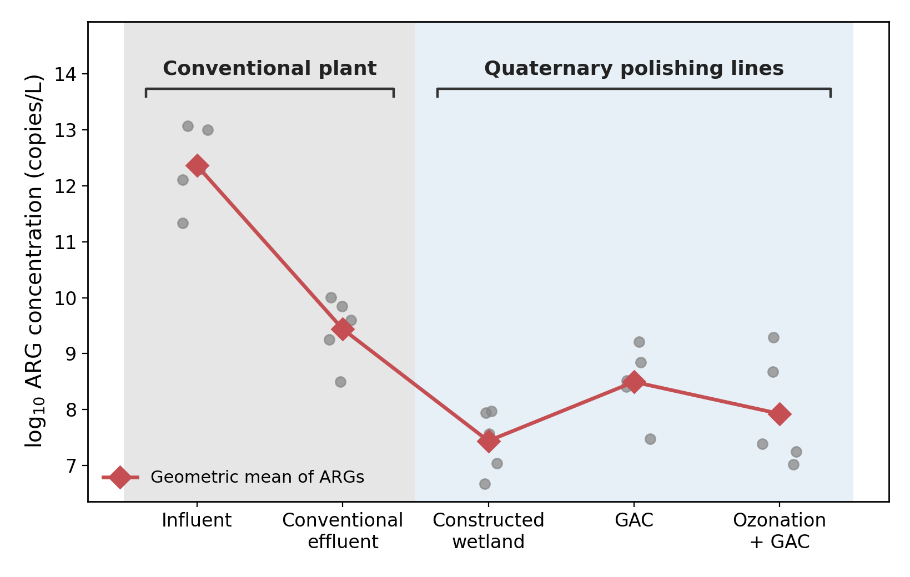
Fig. 1: ARG concentration (log₁₀ copies/L) along the German treatment train: influent, conventional effluent, then the three quaternary line effluents. Individual ARG measurements are plotted as grey points, while the red line tracks their geometric mean across the treatment stages.

However, such ranking is misleading because of variations in biomass removal. After normalization to 16S rRNA, the constructed wetland's selective removal fell to 0.55 log₁₀ (a biomass gap of 1.45), while ozonation + GAC rose to the top at 1.11 log₁₀ (95% CI 0.35–1.87), removing ARGs more selectively than GAC alone (paired difference 0.81, 95% CI 0.45–1.17; Tables 1 and 2, Fig. 2). The constructed wetland's small selective effect with a large biomass gap shows physical capture, while the ozonation + GAC line's small gap may work through chemical oxidation that degrades resistance genes directly.
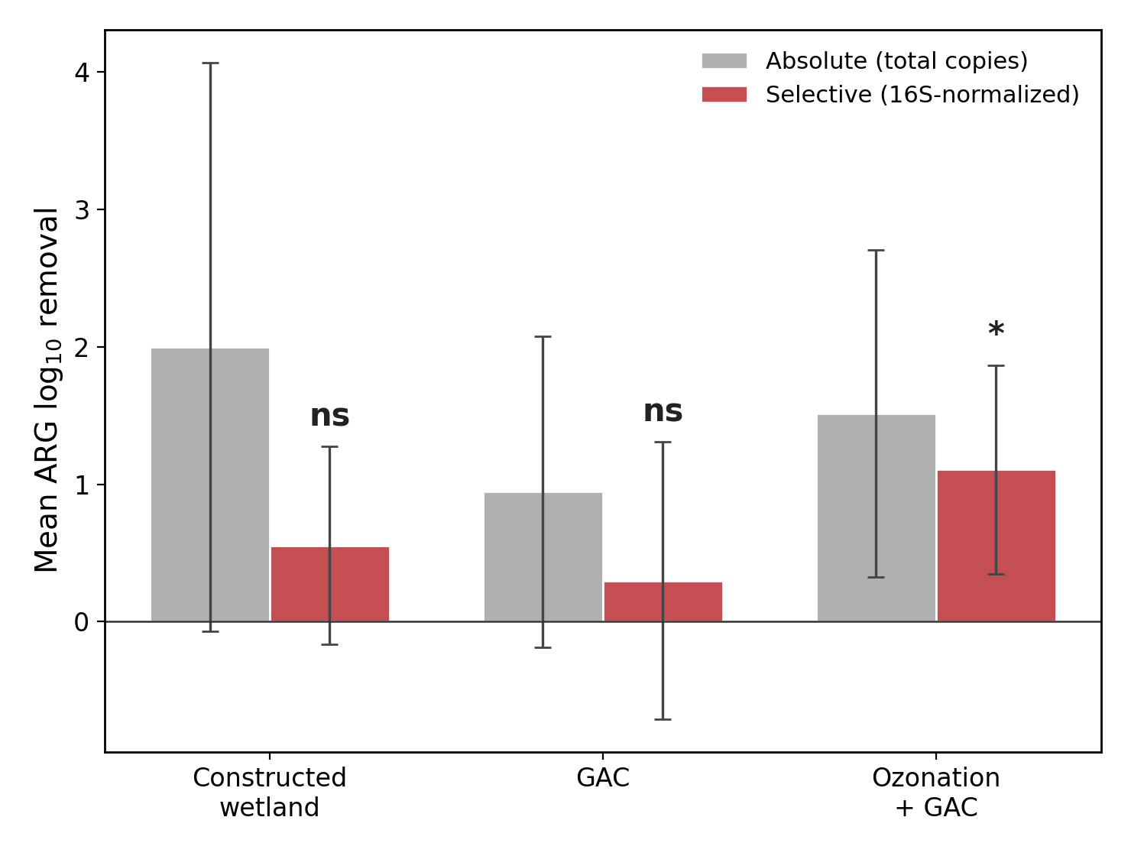
Fig. 2: Absolute and 16S-normalized mean ARG removal per line. Error bars are 95% CIs over the four campaigns (exact values in Table 1). Stars over the selective (red) bars mark removal different from zero by a one-sample t-test (ns p≥0.05, * p<0.05, ** p<0.01, *** p<0.001, **** p<0.0001; n = 4 campaigns). The biomass gap (absolute minus selective removal) is 1.45, 0.6, and 0.4 log₁₀ for the constructed wetland, GAC, and ozonation + GAC: the constructed wetland's large gap is consistent with removal dominated by bacterial capture, and the ozonation + GAC line's small gap is consistent with selective ARG destruction.

3.2 Ozonation + GAC removes ARGs but does not measurably reduce the integron
The ozonation + GAC line removed ARGs selectively but did not measurably reduce the class-1 integron. Selective intI1 removal was 0.05 log₁₀ (95% CI −0.27–0.38), which is not distinguishable from zero (Fig. 3, Table 1). While the ozonation + GAC effluent demonstrates lower resistance-gene counts while keeping the class-1 integron that captures and mobilizes those genes, the constructed wetland showed the opposite pattern: its strongest selective effect was on intI1 (0.81 log₁₀) (Table 2). At the gene level, ozonation + GAC removed ermB and tetW strongly but had smaller effects on removing sul2 and intI1, with the mobile and sulfonamide markers left behind (Fig. 4).
This data reveals two findings. Ozonation + GAC's selective ARG removal does indeed reduce ARGs after adjusting for total bacteria (95% CI 0.35–1.87) and exceeds that of GAC alone (paired difference 0.81, 95% CI 0.45–1.17). Statistical analysis confirms that ozonation + GAC failed to measurably reduce intI1; because the 95% CI for its removal rate includes zero, the treatment had a negligible effect. The stronger intI1 depletion by the constructed wetland is suggestive only, as with only four campaigns the study cannot confidently rank the three treatment systems for intI1 removal (Table 2).

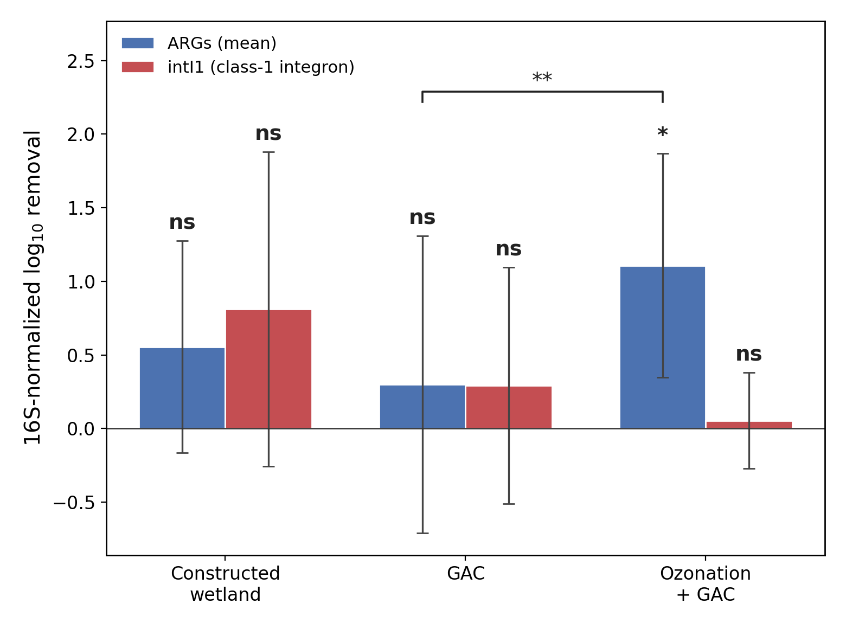
Fig. 3: 16S-normalized removal of ARGs (mean) versus intI1 by line. Error bars are 95% CIs over the four campaigns. Stars over each bar mark removal different from zero by a one-sample t-test, and the bracket marks the paired GAC versus ozonation + GAC contrast (ns p≥0.05, * p<0.05, ** p<0.01, *** p<0.001, **** p<0.0001; n = 4 campaigns). Ozonation + GAC reduced ARGs significantly (*) but did not measurably reduce intI1 (ns); the constructed wetland showed the largest integron depletion, but with overlapping intervals this is not statistically resolved.

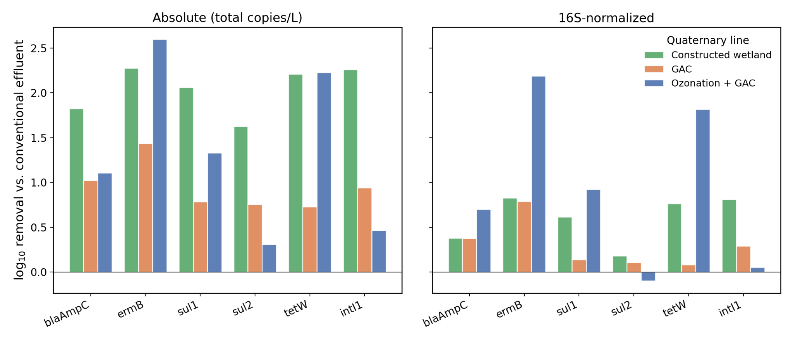

Fig. 4: Per-gene log₁₀ removal by line, absolute (left) and 16S-normalized (right). Ozonation + GAC's selective removal is concentrated in ermB and tetW and is near zero for sul2 and intI1.
Table 1: Selective (16S-normalized) ARG and integron removal per line (mean over four campaigns, 95% CI).
Line | ARG removal (95% CI) | intI1 removal (95% CI) | Biomass gap
Constructed wetland | 0.55 (−0.17, 1.27) | 0.81 (−0.26, 1.88) | 1.45
Ozonation + GAC | 1.11 (0.35, 1.87) | 0.05 (−0.27, 0.38) | 0.41
GAC | 0.30 (−0.71, 1.31) | 0.29 (−0.51, 1.10) | 0.65
Table 2: Paired within-campaign line contrasts (mean difference, 95% CI).
Contrast | ARG removal Δ (95% CI) | intI1 removal Δ (95% CI)
Constructed wetland − GAC | 0.26 (−1.07, 1.58) | 0.52 (−0.64, 1.67)
Constructed wetland − Ozonation+GAC | −0.55 (−1.70, 0.59) | 0.76 (−0.25, 1.76)
GAC − Ozonation+GAC | −0.81 (−1.17, −0.45) | 0.24 (−0.46, 0.94)
3.3 Conventional treatment removes the resistome weakly across three countries
This limitation is not unique to the German site. Scored on the same community-normalized basis, conventional treatment removed the resistome weakly and inconsistently across Germany, Taiwan, and Slovakia (Fig. 5, Table 3). 4 of 12 class-by-site combinations show no reduction or outright increases in the effluent, and sulfonamide resistance is poorly removed at every site (−0.24 to +0.18 log₁₀). The mean selective removal across all cases is only 0.31 log₁₀, about half as much effluent as influent, a small and inconsistent improvement. These are independent studies with different ARG panels and protocols, so we read the cross-site result as a consistency check on the single-site finding rather than a pooled estimate. This shows that conventional treatment lowers ARG counts by removing biomass, not by selectively depleting resistance.
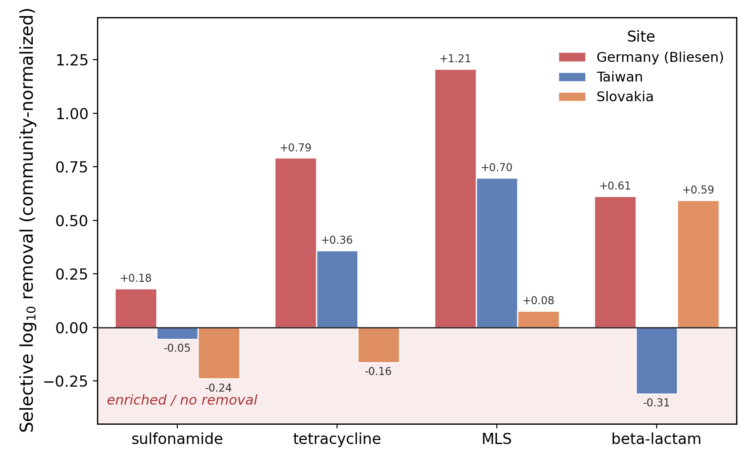

Fig. 5: Selective (community-normalized) log₁₀ removal of four ARG classes by conventional treatment in three countries. Bars in the shaded region (≤ 0) indicate ARGs unchanged or enriched in effluent.

Table 3: Selective log₁₀ removal by ARG class and site, conventional treatment (negative = enriched in effluent).
ARG class | Germany (Bliesen) | Taiwan | Slovakia
sulfonamide | 0.18 | −0.05 | −0.24
tetracycline | 0.79 | 0.36 | −0.16
MLS (macrolide) | 1.21 | 0.70 | 0.08
β-lactam | 0.61 | −0.31 | 0.59

4. Discussion
These results show that lowering ARG abundance is not the same as removing resistance. The metric used most often to evaluate wastewater treatment, absolute ARG copies, ranked the constructed wetland best, but normalization showed that its effect was mostly the physical capture of bacteria rather than selective removal of resistance, unlike ozonation + GAC. The choice of metric reversed both the ranking and magnitude of technologies.
Ozonation + GAC reduced ARGs and did not measurably reduce the class-1 integron, so an effluent that looks cleaner by ARG count can still carry the integron, a marker associated with horizontal-transfer potential. This pattern is consistent with ozone oxidizing accessible DNA and reducing several resistance genes. However, bacteria carrying intI1 may survive or regrow in the GAC biofilm after ozonation, so the mobile-resistance marker remains. It is also consistent with the constructed wetland depleting the integron more through physical retention and creating competition in the wetland material. Several experiments could follow. One is to sequence the DNA around intI1 before and after each line, to see which resistance genes sit on the integron. Another is to measure how much intI1 is inside living cells versus free-floating in the water across ozonation. A third is to identify which bacteria carry the integron. A fourth is to run mating (conjugation) tests that measure how often the integron moves between bacteria, which would turn intI1 from a marker into a measured transfer rate.
Wastewater ARG monitoring should change what it reports. We recommend a standard reporting package for each treatment stage:
- absolute ARG removal (copies/L);
- 16S-normalized (selective) ARG removal;
- the biomass gap (the difference between 1 and 2);
- integron removal (intI1), reported separately from total ARGs;
- integron-associated sul1; and
- intracellular versus extracellular DNA partitioning where feasible, since advanced oxidation may act differently on each pool.

Items 1 to 3 prevent the common case in which a treatment is judged effective from falling ARG counts that mostly reflect biomass loss; items 4 and 5 show whether the mobile fraction persists.

Limitations. The advanced-treatment comparison comes from a single plant over four campaigns with technical replicates, so the confidence intervals are wide and there is a higher level of uncertainty. Only the contrast between ozonation + GAC and GAC alone, and ozonation + GAC's own selective removal, are statistically resolved, while the integron and constructed-wetland results are consistent and biologically coherent but need confirmation at more sites. The cross-country comparison uses independent studies with related but non-identical genes (tetW and tetM; blaAmpC and blaTEM), so it is qualitative. 16S normalization assumes a stable per-genome 16S copy number, and large community shifts through treatment could bias the normalized levels of ARGs. Because ARGs and intI1 are normalized to the same 16S denominator within each sample, the ARG-versus-intI1 contrast, which is the central finding, is less sensitive to this issue than comparisons of absolute normalized magnitudes across sites. Confirming and generalizing these findings will require standardized, multi-site, multi-campaign sampling of advanced-treatment lines with paired influent and effluent metagenomics and transfer assays to test spread.

5. Conclusion
Across conventional and advanced wastewater treatment, removing antibiotic resistance genes is not the same as removing resistance, especially mobile resistance markers associated with horizontal spread. Biomass normalization reversed the initial ranking of advanced technologies and identified ozonation + GAC as the most selective ARG remover, with ozonation + GAC not measurably reducing the mobile class-1 integron. Conventional treatment reduced the community-normalized resistome only weakly across three countries. The contribution is a biomass-normalized and integron-aware evaluation framework. Whether advanced treatment can be engineered to remove the mobile resistome, not just the genes it carries, is the question this work raises and that standardized multi-site studies should answer.

Acknowledgements
This work was supported by Beckman Laser Institute Inc. to LS. High school students participated in the UCSD IEM OPALS internship program. We gratefully acknowledge the support of Leighton Foundation, Ming-Wei Wu, Shu Chien, Lizhu Chen (CorDx Inc.), Xinhua Zheng, David & Leslie Lee, Mingwei He & Wen Shi.

References
[1] C. J. Murray, K. S. Ikuta, F. Sharara, et al., "Global burden of bacterial antimicrobial resistance in 2019: a systematic analysis," The Lancet, vol. 399, no. 10325, pp. 629–655, 2022. doi: 10.1016/S0140-6736(21)02724-0
[2] A. Pruden, R. Pei, H. Storteboom, and K. H. Carlson, "Antibiotic resistance genes as emerging contaminants: studies in northern Colorado," Environmental Science & Technology, vol. 40, no. 23, pp. 7445–7450, 2006. doi: 10.1021/es060413l
[3] T. U. Berendonk et al., "Tackling antibiotic resistance: the environmental framework," Nature Reviews Microbiology, vol. 13, no. 5, pp. 310–317, 2015. doi: 10.1038/nrmicro3439
[4] M. R. Gillings et al., "Using the class 1 integron-integrase gene as a proxy for anthropogenic pollution," The ISME Journal, vol. 9, no. 6, pp. 1269–1279, 2015. doi: 10.1038/ismej.2014.226
[5] W.-Y. Chen, C.-P. Lee, J. Pavlović, D. Pangallo, J.-H. Wu, E. Leung, et al., "Characterization of microbiome, resistome, mobilome, and virulome in anoxic and oxic wastewater treatment processes in Slovakia and Taiwan," Heliyon, vol. 10, e38723, 2024. doi: 10.1016/j.heliyon.2024.e38723
[6] L. Brouwir, H. KleinJan, C. Balent, G. Quabron, I. Salmerón, S. Venditti, F. Gritten, X. Zhao, et al., "Fate and removal of antibiotics and antibiotic resistance genes in a rural wastewater treatment plant: a microbial perspective of nature-based versus advanced technologies," Microorganisms, vol. 13, no. 12, art. 2663, 2025. doi: 10.3390/microorganisms13122663

